Healthcare Tableau Assignment Solution

Q1 Difference Between Tableau Dashboard and Story Point
A Tableau Dashboard is a collection of multiple visualizations displayed together on a single screen to monitor KPIs and interact with data. A Tableau Story Point is a sequence of dashboards or worksheets used to present insights in a storytelling format.
Healthcare Use Cases:
1. Dashboard: Hospital management monitors patient count, treatment costs, and outcomes in one screen.
2. Story Point: A healthcare analyst presents patient distribution, department costs, outcomes, and doctor performance step-by-step.

Q2 Actions in Tableau
Actions in Tableau are interactive features that allow users to interact with dashboards. Common actions include Filter Action, Highlight Action, and URL Action.
Filter Action helps hospital management analyze patient data by selecting a region or department and automatically filtering all related charts. For example, clicking on the North region can show only patients, costs, and outcomes related to that region.

Q3 Patient Distribution
Steps:
1. Drag Hospital_Region to Columns.
2. Drag Patient_ID to Rows and use COUNT.
3. Choose Bar Chart from Show Me.
4. Add title: Total Patients by Hospital Region.
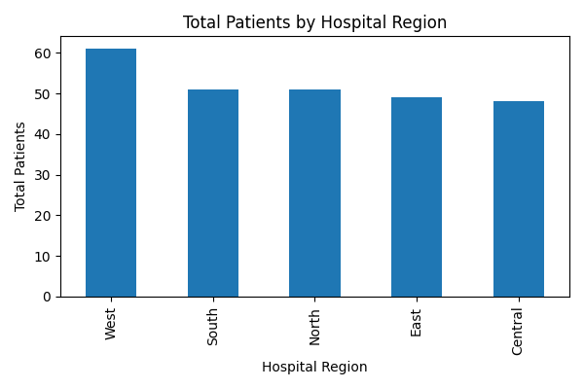
Insight: The chart shows which hospital region handles the highest number of patients.

Q4 Department Performance
Steps:
1. Drag Department to Columns.
2. Drag Treatment_Cost to Rows.
3. Use Bar Chart and add labels/colors.
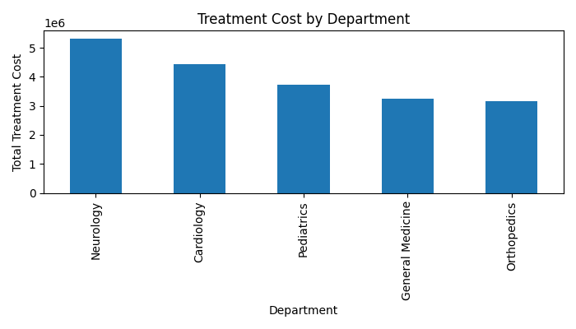
Insight: Neurology department generates the highest treatment cost.

Q5 Treatment Trend Over Time
Steps:
1. Drag Admission_Date to Columns.
2. Drag Treatment_Cost to Rows.
3. Select Line Chart.
4. Add month filter from March to September.
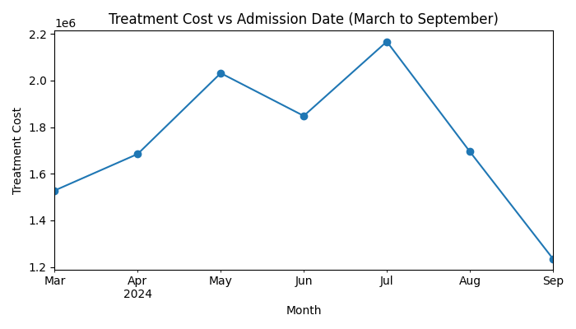
Insight: The trend shows monthly fluctuations in treatment cost.

Q6 Outcome Analysis
Steps:
1. Drag Outcome to Color.
2. Drag Patient_ID to Angle and use COUNT.
3. Select Pie Chart.
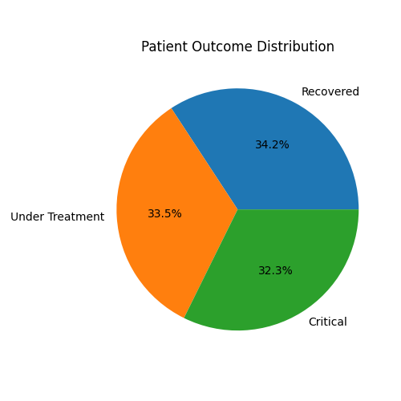
Insight: The pie chart displays patient recovery and critical case distribution.

Q7 Doctor Performance & KPI Analysis
Task A - Doctor Performance
1. Drag Doctor_Name to Rows.
2. Drag Treatment_Cost to Columns.
3. Sort descending for ranking.
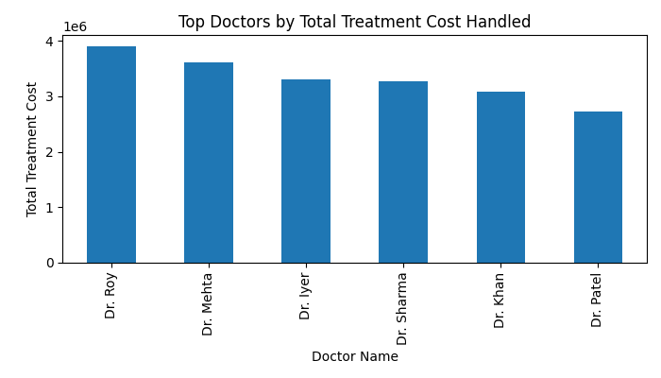
Insight: Doctors handling higher treatment costs may be managing more complex cases.
Task B - KPI Creation
Total Patients Treated KPI: 260

Q8 Interactive Dashboard
Dashboard should contain Region Chart, Department Cost Chart, and Outcome Chart. Add filters for Hospital Region and Department.

Q9 Storytelling Flow
1. Patient Distribution
2. Department Cost Analysis
3. Outcome Analysis
4. Doctor Performance

Q10 Final Answers Based on Visuals
1. Department with highest treatment cost: Neurology
2. Region with highest critical patients: West
3. Hospital management can allocate more resources to high-cost departments, improve staffing in regions with more critical patients, and monitor doctor performance to optimize treatment quality and operational efficiency.

